Jog wheels with built-in displays for DJ performance

Visual guidance on jog wheels
2 displays on jog wheels
- 2 circular displays per platter
  - Blue: speed + scratch viewer
  - White: position viewer
- Great for scratching: the display shows the scratch length and starting point
Focus on the performance and audience
- Mix/scratch status visible on jog wheels
- No need to peek at computer screen
Emulates motor-driven rotation
- Displays turn at 33⅓ or 45 RPM
- The DJ sees the impact of pitch settings as rotation speed shifts up or down
Changes the look and feel of computer DJing
- The DJ controller feels like DJ CD players
- The main display is on the jog wheels, not the computer

DJ software included

Controls
Large, rugged 2-deck DJ controller
- Controls 2 virtual decks + virtual mixer
- Rugged black casing
The next step in jog wheels
- Large 5.9”/15 cm jog wheels: like 2 DJ CD players
- Touch detection + visual guidance
- High resolution, low latency
2x4 progressive pads with colored lights
- 2 sets of 4 pads send instant commands
- Intuitive for samples + cue controls
- Colors show the types of commands
Air control
- Instant, touchless control of effects
- The audience sees the performance thanks to a control range of 8”/20 cm

Hercules DJControl Jogvision

References / Barcodes
EMEA 4780547 / 3 36293 473863 1
U.S./Canada 4769250 / 6 63296 41912 5
UK 4768210 / 3 36293 474408 3

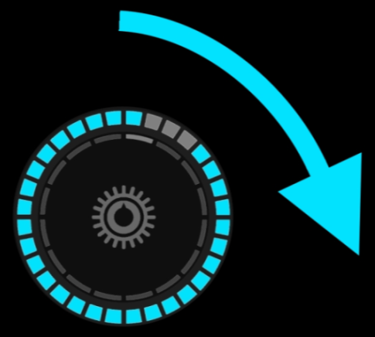 | 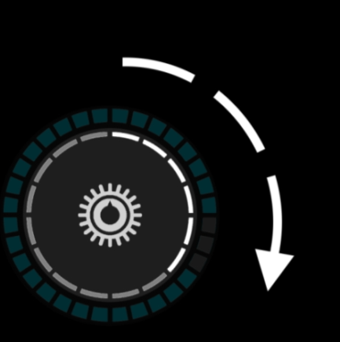 | 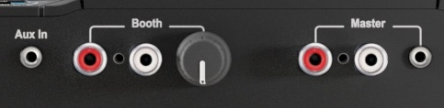  Outputs  Master 1-2: 2 RCA + 1/8” stereo  Booth 1-2: 2 RCA    Headphones: 1/4” + 1/8” (stereo)  Inputs  Mic 1/4” microphone in  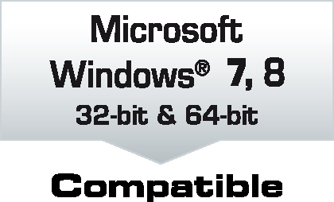  Aux 1/8” stereo line in  Resolution  16/24-bit audio at 44.1/48/96 kHz
Playback speed | Position in the track | Pro DJ audio interface
Mechanical specifications
Enclosure 17.9 x 10”/45.5 x 25.4 cm
Jog wheels 5.9”/15 cm diameter
Weight 5.5 lbs/2.5 kg
Standards
Audio
- ASIO + WDM in Windows®
- Core Audio in Mac OS®
Controls
- MIDI (extended MIDI on faders + potentiometers)
- HID

Minimum system requirements
2 GHz Core 2 Duo/Athlon 64 X2 or faster CPU
2 GB RAM or more, USB high speed port
Internet access
Operating system (32-bit/64-bit)
Mac OS® 10.7/10.8/10.9/10.10
Microsoft Windows® 7/8
Ready for Serato DJ
Serato DJ Intro included
Compatible with Serato DJ (upgrade required)


